# Lab: Induction Machine Tests

**Aim: To produce an induction motor simulation in Simulink and perform typical parameter tests.**

**If you have not already re-read your lecture notes on induction machines tests, close this coursework, go and read the notes and then re-start the coursework. If you start this without having an understanding of what parameters tests are, you will not benefit from this lab.**

## Induction machine equivalent circuit

The equivalent circuit of the induction machine is shown in Figure 1. The following three tests :

1. DC test
2. No Load test
3. Blocked Rotor Test

are used to determine the motor parameters: R1, R2, X1, X2, Xm. These values are ***per phase*** values.

Figure 1 Equivalent Circuit of Induction Motor

R2

R1 X1

V1

R2(1-s)/s

X2

Xm

Iϕ

I1

I2

## Induction Motor DC Test

Figure 2 shows an induction motor with three phase windings (A, B, C) on the stator and three windings (a, b, c) on the rotor. Identify these in the diagram.

Each phase winding will have a resistance, R1.

The diagram shows a dc voltage supply across phase A and B, that is voltage VDC is across two windings ( 2*R1). Phase C is connected to ground.

This test is done in order to provide the stator resistance, R1 and for the DC test, the current is reduced to produce rated current (operating current condition). To reduce the current to near rated current, additional resistors are included in the series path of the phase windings.

Identify the measurement blocks for voltage (across which points?), current and how the resistor value, R1, has been calculated.

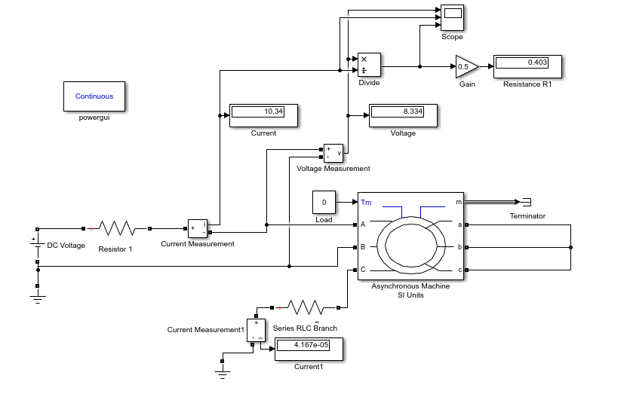

Figure 2 Simulink Circuit for DC test

We need to model the Simulink circuit in Figure 2 for a 5 HP, 208 V, 60 Hz, Y-connected machine. HorsePower (HP) is a traditional measurement of power where 1 HP =0.746 kW. The components that are used in the Simulink model are given below.

### Asynchronous machines in Simulink

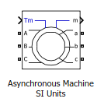

**Asynchronous Machine SI units** is found in (Matlab v2020a)

Simscape/Electrical/Specialized Power Systems/ Fundamental Blocks/ Machines

Double click on the icon.

Look at the rotor types but Leave as a **wound rotor.**

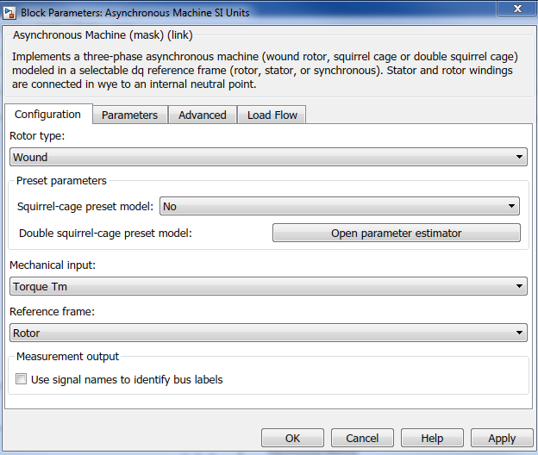

Click on the Parameters Tab.

We are asked for

Power, VLL, f

Stator resistance and Stator inductance

***Referred*** rotor resistance and rotor inductance (note the dashes).

The mutual inductance Lm

We will leave the inertia ( J = 0.5 kg m2) . Refer back to the dynamic section on why we have an inertia and not a mass for the rotational system.

We may want to re-run with different machine parameters, so we will write parameters as variable names and write a quick script to run in Matlab to update the model. Use the names as shown below then click OK and close the box. There may be some red warning signs – this is because you have not yet defined what the parameter values are. We will do this soon.

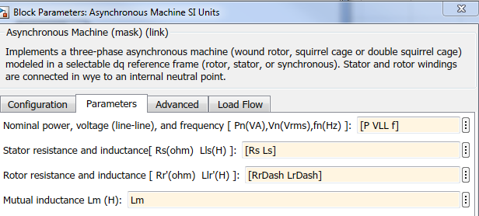

Connect the right hand side (rotor side) a,b,c connections together.

Copy a constant block from the Simulink/Commonly Used Blocks and connect it to the Load terminal of the motor, Tm. Set the constant to ‘0’.

**Motor Parameter script**

Create a matlab script ( m file) for the parameters:

The motor will operate at P = 3.73 kW (5 HP) , VLL = 208 V and f = 60 Hz. The values of our induction motor , all referred to the stator side, are:

Rs = R1 = 0.403 Ω , Xs = X1 = 0.740 Ω , Rr = R2 = 0.511 Ω , Xr = X2 = 0.740 Ω , Xm = 12.258 Ω .

‘1’ or ‘s’ indicates the stator side resistance and reactance and ‘2’ or ‘r’ indicates the rotor side.

Note that we are given the reactance values X (= w*L), but we need to enter the inductance in the matlab script:

L = X/ω , where ω = 2 * π * f.

With the parameter names given we can write a matlab script to define the following parameters

P = 5 * 746; % units VA: power input HP* 746 W/HP

VLL = 208; % units V: VLL

f = 60; % units Hz

% Note the inductances are derived from reactances given at f=60 Hz

% X = w*L, but we need to enter L : L = X/w

% omega = 2 * pi * f

omega60 = 2*pi*60; % units rad/s

Rs = 0.403; % units Ohms : stator resistance

Ls = 0.740/omega60; % units Henries: stator inductance

RrDash = 0.511; % units Ohms : rotor resistance referred

LrDash = 0.740/omega60; % units Henries : rotor inductance referred

Lm = 12.258/omega60; % units Henries : magnetising inductance

Run the script. Check that these values appear in your workspace and that your induction machine has no longer any warning signs.

### DC Input

Since this is a DC test we are using a DC supply and will change a resistance value until we reach the rated current through the phase windings.

Find the DC voltage source in

Simscape/Electrical / Specialized Power Systems/ Fundamental Blocks/ Electrical Sources.

Set the value to be 120 V.

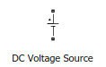

### Resistors and Grounds

Copy a **series RLC branch** and a Ground to your simulation.

Simscape/Electrical / Specialized Power Systems/ Fundamental Blocks/ Elements

 

Create a resistor from ‘Series RLC branch’ and call it Resistor 1. Create another resistor, Resistor 2, as a 10 kΩ resistor in series between phase C of the motor and the ground that you have copied in to the simulation.

The DC voltage is connected across phase A and B of the motor. The resistor is in series to limit the current to its rated value.

If the power factor were 1, calculate the rated value of the current?

Hint: This is a Y-connected machine. Remember to use your power triangle.

### Measurement blocks

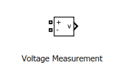 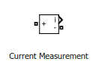

Copy the current and voltage measurement blocks from the library at:

Simscape/Electrical / Specialized Power Systems/ Fundamental Blocks/ Measurements

Connect the voltage and current measurements to measure the voltage across the two phases and the current through phase A.

Also add a current measurement block to measure the current through Phase C.

### Display Outputs and Terminator

 

from Simulink/ Sinks

Connect a Display box for the voltage and current, and a terminator to the ‘m’ terminal of the induction motor. This terminal allows us access to the internal stator/ rotor current and phases, which we are not using at this time.

You might like to go into the Simulink library section and look in the maths section for a divisor: this will provide the resistance as ‘V/I’.

We will also need a gain block from the Commonly Used Simulink library.

Use the Library Search tool and search the Simulink library for a powergui block. Put one somewhere on your diagram.

### Run Simulation

Set the simulation time to be 15 seconds. This will allow the simulation to reach steady state.

Start the value of Resistor 1 at 6 Ω in your script file. Run the simulation. Check the current value. Increase the value of Resistor 1 until you have a current value just below rated. It does not have to be exact.

Once you have the current at rated value, note the phase voltage and current and calculate the stator phase resistance, R1.

In practice this is an approximation to R1 since there are several effects that have not been included, such as temperature or ‘skin effects’. Current is uniformly distributed across the cross-section of a conductor. However, when an AC current flows through a conductor, the current density is greater at the surface and decreases closer to the centre of the conductor. The consequence for us is that, in real systems, the resistance is slightly higher for an AC current than a DC current.

Save your simulation as ‘InductionMotorDCtest’. Close the model.

## No Load Test

We are now going to run a no-load test on our induction motor. Re-open the previous model and save it as ‘InductionMotorNoLoad’.

**No Load Test (measurements):**

**V1,NL, I1,NL and the Power, PNL at rated frequency.**

In the following, be VERY clear as to whether you are referring to a single phase measurement or a 3 phase power output. Factors of 3 are involved in some places.

From your notes:

XNL ~ X11=X1+Xm ,

or , using a phase measurement, XNL = QNL phase/ Iphase2

If the no load power factor ‘pf’ is small, QNL≫ PNL and R1 ≪ X11, so an approximation:

$X_{NL}≈\frac{V_{1,NL}}{I_{1,NL}}$

We will now develop the Simulink model in Figure 3 for the No Load Test. Look at the diagram and notice the differences from the DC test model.

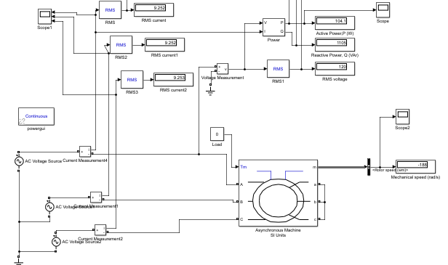

Figure 3: No Load Test on Induction Machine: Simulink Model

### Power Supply

Remove the DC power supply and look for an AC voltage source

Simscape/Electrical / Specialized Power Systems/ Fundamental Blocks/ Electrical Sources.

This is a three phase system. Copy the voltage supply three times, connect a common ground. Note that the voltage source requires you to enter the ‘peak’ value, NOT the rms value. Enter the values of voltage and frequency as ‘Vpeak’ and ‘ftest’. Answer the questions from the parameters given and further calculations.

What is the line voltage?

What is the phase voltage?

What is the rms voltage?

What is the peak voltage?

What are the phase angles for each of the power supplies? This is important to get correct.

Enter calculations for these in your script. Remember to include the name ‘Vpeak’ as the name for the peak voltage.

ftest will be 60 Hz for the No Load test.

Connect a power supply with a current measurement to each phase.

### Measurements

Include an active and reactive power measurement block, and an RMS block

Simscape/Electrical / Specialized Power Systems/ Fundamental Blocks/ Measurements/Additional Measurements

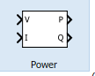 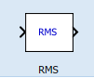

Connect an RMS block to phase A voltage and current and display the output. You need to input the frequency (since the rms is done per cycle). Remember that we are using the variable ‘ftest’, in order that we can change it at a later date.

Connect the PQ block to the phase A voltage and current to get the phase A power and reactive power.

Double click on each block and check the frequency and initial rms values for current is 10 A and voltage is 120 V.

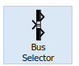

From Simulink/Signal Routing find the Bus selector block. Connect this to the m port of the induction motor. Double click on the selector and navigate your way to the Mechanical signals. Choose Rotor speed (wm) and click select. Then click OK.

You should now have one signal output and can add a display to show this value.

Now that you have completed the model, identify the following signals, units and any appropriate equations:

1. The input load to the machine.
2. The measured output from the machine on the mechanical side.
3. The input voltage supply.
4. The measurements on the electrical side (what is actually measured).
5. Any further calculations from the measurements.

### Run the simulation.

We will leave the Load torque as ‘0’ for a no load situation. Note that we have left the motor inertia and friction as before.

1. From the No-load test: write down the following Pphase, QPhasw, ω m, Vphase Iphase
2. Calculate XNl and Prot showing your working.

Save and close the model.

## Blocked Rotor Test

For a blocked rotor test, what parameters do we wish to calculate? Look back at your notes before starting this section.

The blocked rotor test is often done at different frequencies from rated frequency.

Reopen the NoLoad model and save as ‘InductionMotorBlockedRotor’.

### Blocked Rotor Procedure : From Notes.

1. **Use the simulation you will develop to do the Blocked Rotor Test.**
2. **Provide the following (measurements): V1,BL, I1,BL and the Power, PBL at reduced frequency from the simulation.**
3. From these we determine SBL  and QBL
4. The reactance is calculated as before but scaled up due to the reduced frequency of the test. Note that if Q is phase reactance, we don’t need to divide by the 3 phases.
$$X_{BL}=\left(\frac{f_{rated}}{f_{BL}}\right)\frac{Q_{BL}}{qI_{1,BL}^{2}}=X_{1}+X_{2}$$

5. We need an empirical table to determine X1 and X2. Since we are using a Wound Rotor Induction Machine, the reactances X1 and X2 are equal. Therefore we use the value of k = 1 in the following expression. Solve this using the matlab ‘roots’ expression to find the value of X2 (= X1).

k2 X22  + (XBL(1-k) –XNL(1+k))* X2 + XBLXNL = 0

1. Xm = XNL – X1
2. RBL = PBL / (q*I1,BL2) : If PBL is phase power we don’t need to divide by 3.

$$R_{2}=\left(R_{BL}- R_{1}\right){\left(\frac{X_{2}+X_{m}}{X_{m}}\right)}^{2}$$

### Blocked Rotor Model development

Open the induction motor block and set the mechanical input option to ‘Speed w’. Save and close the window. Change the name of the constant block feeding the input from torque or load to Speed. Set the constant block to 0.

In the Matlab script, set the value of ftest to 15 (Hz): this is 25 % of the rated value. It is suggested that the test frequencies are not lower than this. In our simulation we do not have all the nonlinearities of a real experimental set-up, but we are following similar procedure.

Set Vtest ***initially*** to be 30 V (rms) in the Matlab script. Calculate the peak value of this test value in your matlab script.

Update your voltage sources with the correct test voltage.

### Run the Simulation

The rated current is about 10.2 A.

Run the simulation. **If the current is above rated, lower the voltage by using Vtest to take the current to just below rated.** Do not spend too long on this. Note that Vtest is the rms value and your script should calculate the updated peak values.

a) From the Blocked Rotor test: write down the following Pphase, QPhasw, ω m, Vphase Iphase

(b) What are the output equivalent circuit parameters? Compare them with the ones you input to the induction motor at the beginning. Comment.

Original:

Calculated:

Save your model.

# Instructions for Coursework for Electrical Machines

## Report

You have to complete a combined coursework: Section A is the results from Lab 6 and Section B is the results from this induction machines lab. The report is submitted through Turnitin in the Coursework CW1/CW2 area.

### Front Page

On the Front Page you should have

(Your name/ Student ID)

Title of Coursework

### Structure

Your report should consist of Numbered Sections, corresponding to the Tasks in Lab 6 and Lab 7. The numbered section may contain text/ calculations /plots/ Matlab code/ Simulink diagrams.

**You are NOT asked to provide copies of material/pages from the lab instructions. Marks will be taken off for not following this guideline.**

### Comments

The marking schedule is included on the last page.

Ensure any matlab code has clear comments indicating what it is meant to do.

Ensure that any Simulink model is legible and has clearly named blocks.

## Induction Machine Lab Tasks

Include a table with a list of Parameters/ units/ brief description: used in your model.

### Task 1 Induction Machine Description (8 marks: 6+2)

1. Write a brief paragraph explaining how a three phase induction motor works. Be clear when you refer to rotating magnetic fields and their interaction.
2. What do we mean by an ‘asynchronous motor’?

### Task 2 DC Test (6 marks: 2 + 4)

1. The reactance XL, will depend on the frequency. We are asked to input the inductance for the machine, not the reactance. Why is that?
2. Write down an explanation and calculations for how you calculated R1.

### Task 3 No Load Test (16 marks : 4+2+4+6)

1. Being VERY clear as to whether you are referring to a single phase measurement or a 3 phase value:

* Write down the No Load measurements e.g. V­1­, NL , …..
* Write down expressions for SNL and QNL  (the apparent and reactive power) in terms of the No Load measurements.
* Write down an expression for the rotational losses of the machines that can be calculated from your measurements.

1. Write down the line voltage, phase voltage, rms voltage and peak voltage for this test.
2. Write down the following information from your simulation

* the input load to the machine.
* The measured output from the machine on the mechanical side.
* The measurements on the electrical side (what is **actually** measured) and what is calculated from the measurements.

1. Write down the values of Pphase, QPhasw, ω m, Vphase Iphase from the NO Load test and calculate XNl and Prot showing your working.

### Task 4 Blocked Rotor Test (20 marks: 4+4+ 8 + 4)

1. What do we mean by blocked rotor test? How do we achieve this in practice?
2. The blocked rotor test is performed at reduced frequency. Explain why.
3. From the Blocked Rotor test: write down the following Pphase, QPhasw, ω m, Vphase Iphase and calculate the output equivalent circuit parameters?
4. Compare the calculated values with the ones you input to the induction motor at the beginning. Comment.

Original:

Calculated:

### Scripts & Screenshots (10 marks: 6 + 4)

1. Include your matlab **scripts** for each of the three tests. Make sure there are comments and include your name at the top.
2. Include legible screenshots of **two models** :the **DC test** and the **Blocked Rotor Test**. Annotate each Simulink model with your name .